***PostgreSQL Assignment***

● Create a fresh database titled "university_db" or any other appropriate name

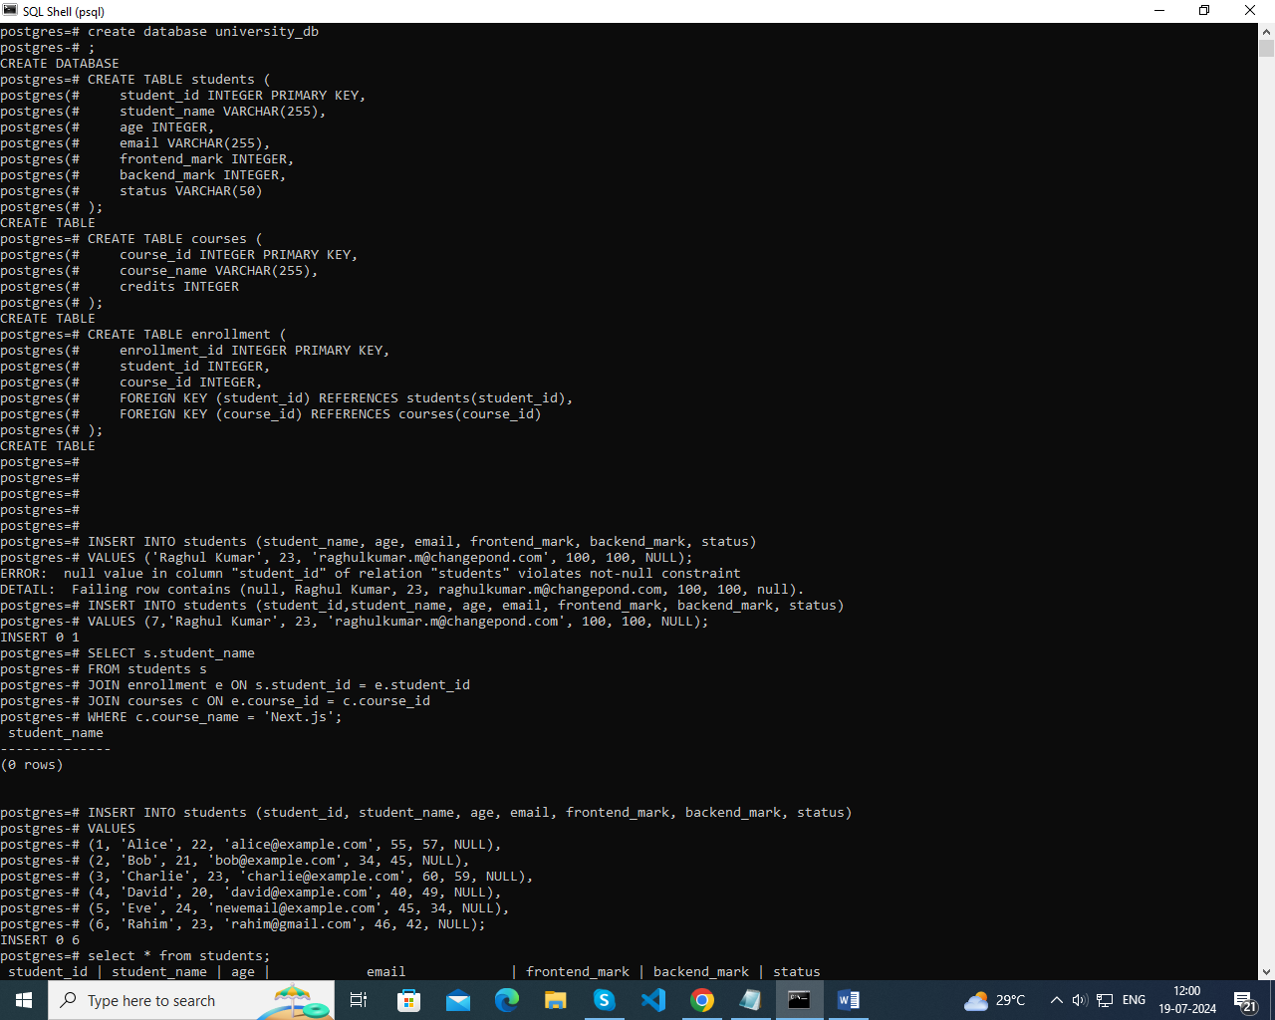

Create a "students" table with the following fields:

● student_id (Primary Key): Integer, unique identifier for students.

● student_name: String, representing the student's name.

● age: Integer, indicating the student's age.

● email: String, storing the student's email address.

● frontend_mark: Integer, indicating the student's frontend assignment marks.

● backend_mark: Integer, indicating the student's backend assignment marks.

● status: String, storing the student's result status

Create a "courses" table with the following fields:

● course_id (Primary Key): Integer, unique identifier for courses.

● course_name: String, indicating the course's name.

● credits: Integer, signifying the number of credits for the course.



Create an "enrollment" table with the following fields:

● enrollment_id (Primary Key): Integer, unique identifier for enrollments.

● student_id (Foreign Key): Integer, referencing student_id in "Students" table.

● course_id (Foreign Key): Integer, referencing course_id in "Courses" table.



● Insert the following sample data into the "students" table:



● Insert the following sample data into the "courses" table:

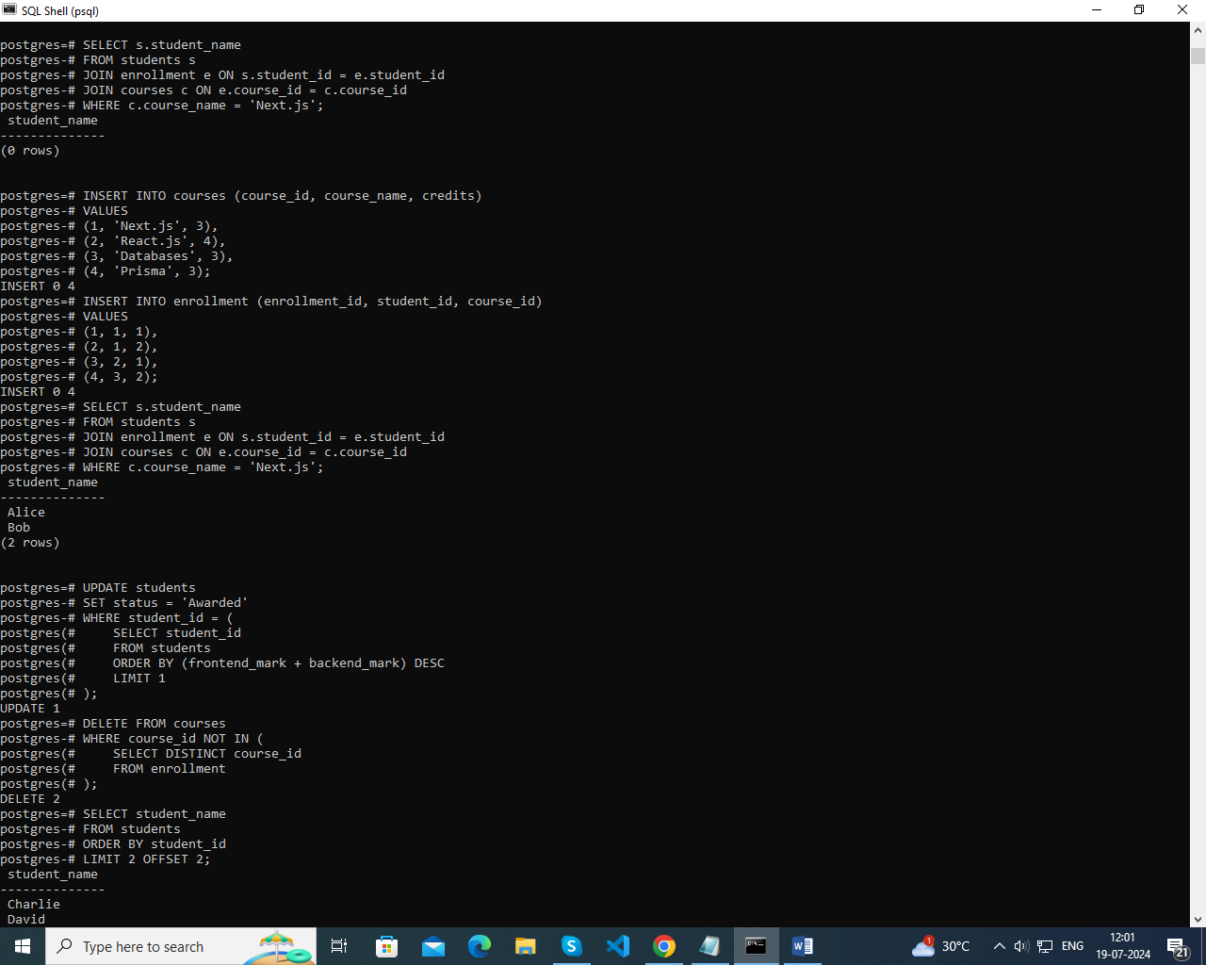

● Insert the following sample data into the "enrollment" table:

Query 1: Insert a new student record with the following details:

● Name: Raghul Kumar M

● Age: 23

● Email: raghulkumar.m@changepond.com

● Frontend-Mark: 100

● Backend-Mark: 100

● Status: NULL

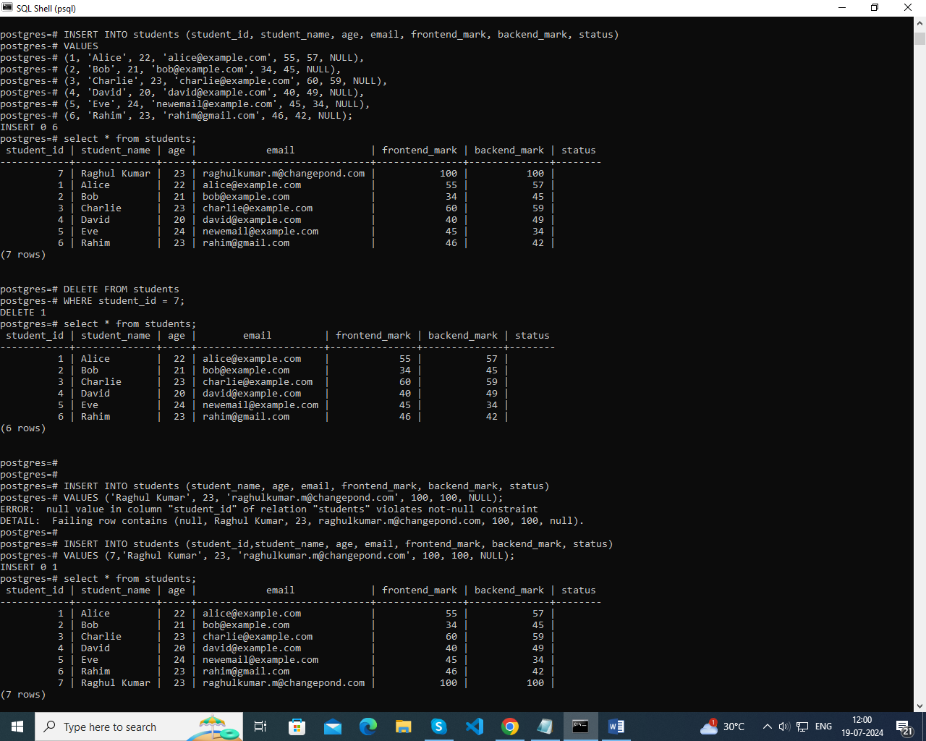

Query 2: Retrieve the names of all students who are enrolled in the course titled 'Next.js'.



Query 3: Update the status of the student with the highest total (frontend_mark + backend_mark) mark to 'Awarded'



Query 4: Delete all courses that have no students enrolled.



Query 5: Retrieve the names of students using a limit of 2, starting from the 3rd student



Query 6: Retrieve the course names and the number of students enrolled in each course.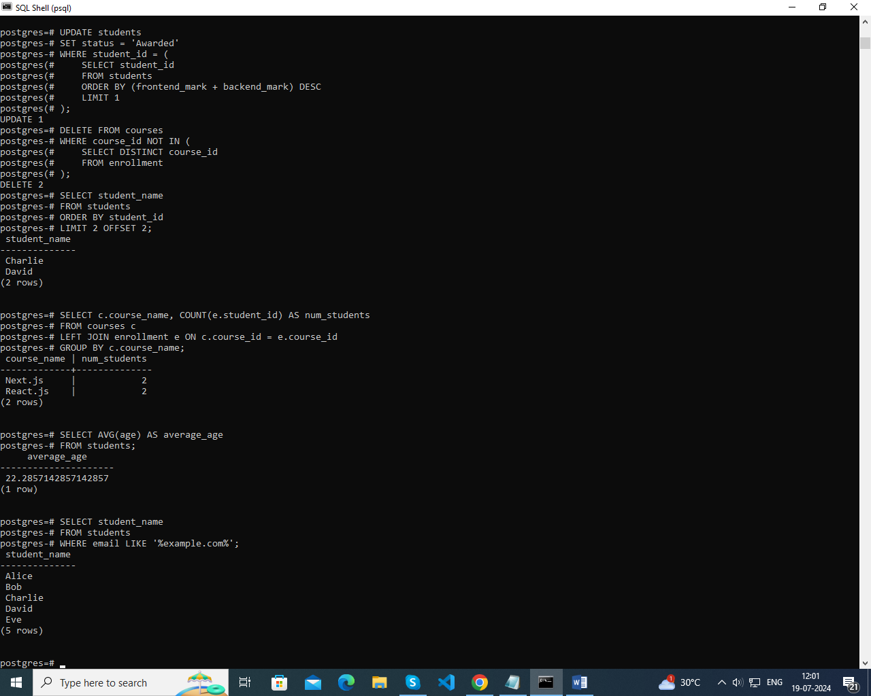

Query 7: Calculate and display the average age of all students.



Query 8: Retrieve the names of students whose email addresses contain 'example.com'.

